**Institute Of Business Management**

**23, April 2022**

**IOT Based Smart Irrigation System using Cisco Packet Tracer (8.1.1)**

**Huzaifa Masood, Muhammad Murad Siddiqui**

**College of Computer Science and Information Systems, Karachi**

***Abstract***— Irrigation system or water system is a procedure for providing water to plants as uniformly as could really be expected. The Internet of Things (IoT) is used through the usage of smart devices and technological devices as well as sensors that are connected to the internet with the aim that they can be controlled and observed from a distance by the client. The implementation is carried in this project by mimicking a smart irrigation system framework utilizing the Cisco packet tracer recreation programming with the new adaptation Cisco Packet Tracer 8.1.1 (64-digit). This innovation can be utilized to make a brilliant water system framework that incorporates devices, for example, a lawn sprinkler, temperature monitor, humidity monitor, cable modem, home gateway, MCU board and different devices that computerize the watering framework and remotely screen the ecological circumstances for ideal plant development. The house is associated with the entirety of the hardware which helps farmers to grow farms with ease.

.***Keywords***—Cisco Packet Tracer, Internet of Things and Smart Irrigation System.

# **INTRODUCTION**

IoT means ‘Internet of Things’, Kevin Ashton began the expression in 1999. [1] IoT is like increased reality, top quality video web based, self-driving vehicles, smart conditions, e-medical services, and different innovations are currently typical. A definitive objective of IoT is to bring attachment and-play innovation that furnishes end-clients with straightforwardness of purpose, remote access control, and configurability. It basically tries to appropriately explain the physical objects and arrangements using a combination of sensors, software, processing abilities as well as various other technologies that are connected together to carry out the exchange of data with other systems and devices that are connected to the internet simultaneously.

[2] Each item is connected to one more by an extraordinary recognizable proof, permitting information to be traded without the requirement for human association. It empowers the improvement of answers for better normal asset the executives. As per the IoT idea, brilliant items furnished with sensors empower connection with the physical and consistent universes.

[3]Farmer and homeowners with a grass space for cultivating and plant the board experience various difficulties because of changing natural conditions. Ranchers and families can utilize IoT innovation to keep an appropriate water system framework that can be computerized and controlled from a distance from anyplace on the planet. In the present chaotic climate, assuming the mortgage holders can't take care of their plants, this innovation can help them in basically observing the devices, so defeating the downside of manual checking.

[4]Farmers and mortgage holders with a yard space for cultivating and plant the executives experience various difficulties because of changing natural conditions. Ranchers and families can utilize IoT innovation to keep a legitimate water system framework that can be mechanized and controlled from a distance from anyplace on the planet.

In the present rushed climate, in the event that the property holders can't take care of their plants, this innovation can help them in basically observing the device, so defeating the downside of manual checking.

[5]On account of ongoing headways in IoT and WSN innovations that can be utilized in the development of these items, we give a study pointed toward summing up the present status of the craftsmanship in the field of frameworks. Shell of water system as far as water system frameworks, we decide the boundaries that are observed.

Water sum and quality, soil highlights, and weather patterns are exceptionally significant elements to consider. We provide you with an outline of hubs and remote advancements that are generally usually utilized. At long last, we'll discuss the challenges and the best arrangements.

[6]The Smart Irrigation framework in this undertaking comprises of savvy devices that robotize the water system framework, permitting property holders to computerize the yard sprinkler/watering framework in light of the degree of water shown by the water level screen, which brings about turning the water channel on or off on a case by case basis. The Smart Irrigation framework computerizes an assortment of undertakings, for example, keeping up with plant moistness levels. Whenever the mugginess level arrives at a not set in stone by the proprietor, the moistness sensor screens it and turns the humidifier on or off.

[7] New water shortage is turning out to be a greater amount of an issue, especially in Mediterranean nations and southern Asian nations like Pakistan. The Mediterranean nations are the most powerless against dry spell among Europe's nations.[8] A connection between environment approaches and water the board has been laid out. Water the executives is affected by an assortment of elements, including water interest from different areas and the impacts of different levels of warming on hydrological assets. Environmental change and its ramifications are regularly examined in articles about water assets and farming.

Temperature screen, Pressure screen, Carbon dioxide indicator, Carbon monoxide identifier, Wind locator, and Humiture screen are a portion of different factors that are significant for vivacious and verdant plant development.

[9] The smart devices are connected to the home gateway and might be controlled and observed remotely through a tablet, PC, or cell phone. It additionally contains a creature movement recognizing alert. It works with the assistance of a microcontroller and cautions the proprietor at whatever point movement is identified close to the water system field.

[10] The reenactment discoveries show that savvy devices are associated with the home gateway and can be controlled, checked, and mechanized somewhat founded on the requirements.

Cisco Packet Tracer is a visual reenactment device that permits clients to make network geographies and recreates current PC organizations. It gives a virtual order line interface for reenacting switches and switches.

The remainder of the paper is laid out as follows: (I) the principal segment presents the Internet of Things (IoT) and its application to the Smart Irrigation System., (II) Contains the Literature Review of the projects, (III) contains the characteristics of the Smart irrigation system, (IV) it contains implementation and discussion, (V) concludes research work.

# **LITERATURE REVIEW**

Utilizing the packet tracer demonstrating programming, a nursery observing framework in light of IoT is built.[11] It utilizes measurable information from sensors as well as information put away in the cloud. A computerized framework for water system is created by dissecting the dampness level of the ground. This framework utilizes two microcontrollers, Raspberry pi and Arduino individually. [12] The framework is a smart home framework that utilizes Cisco packet tracer and IoT innovation to robotize different dwelling tasks. The subject goes for the gold level checking and control of information for a farming observing framework that utilizes Raspberry Pi and cloud-based IoT devices to screen ongoing information from the yield field. [13] The utilization of computerization frameworks in remote innovation enjoys different benefits that wired frameworks can't give, as expressed in this paper. Remote frameworks get a good deal on establishment since they require little equipment and require no wiring. Remote frameworks can be scaled and extended on a case by case basis. One more significant part in controlling devices from one side of the planet to the other is approaching the web. [14] A Microcontroller (MCU-PT) and Home Gateway are utilized to control the sensors, as proposed in this work, which gives a programming climate to controlling devices associated with the home passage.

# **FEATURES**

Our model “Smart Irrigation system” has been completed on Cisco Packet Tracer (8.1.1) software.[15] Cisco Packet Tracer is an innovative network simulator that is used in building different network with routers, switches, boards. It is used for making models. Smart Irrigation system design includes a mobile/tablet and home gateway is used to connect with different devices such as temperature monitor, garden sprinkler, water level monitor, and more sensors. Home gateway functions to connect all the smart devices, and mobile/tablet is used for communication with other smart devices.

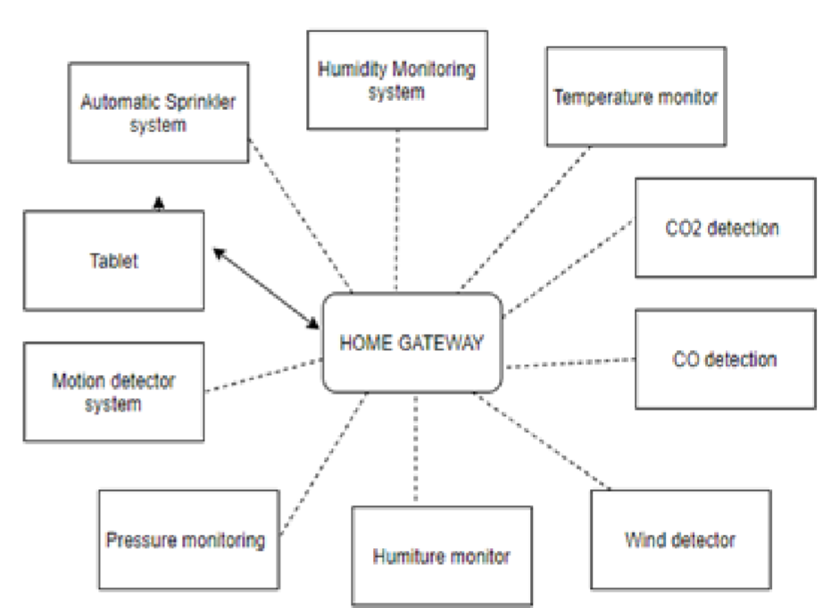

*Figure 1. Block Diagram of Smart Irrigation System*

Fig 1 shows block diagram of the Smart Irrigation system, implemented using the Cisco Packet Tracer. The block diagram contains 10 different IoT systems, some of them are Automatic sprinkler system, humidity monitoring system, Temperature monitor, Pressure monitoring, Motion detector system, Humiture monitor, and many more. All of the above IoT systems are connected through gateway to the internet and it can be controlled through mobile or tablet online with the establishment of connection in the device.

*Table 1: Devices Used*

|  |  |  |
| --- | --- | --- |
| **Sr.**  **No.** | **Device** | **Function** |
| **1** | Server | The home framework is associated with a cell network by means of a server. |
| **2** | Cable Modem | Provide internet connection between devices. |
| **3** | Home gateway | The function of home gateway is to control smart devices via gateway port. |
| **4** | Switch | Different devices can communicate with each other through switch. |
| **5** | Lawn  Sprinkler | It is a sprinkler for Lawn/Garden. |
| **6** | Water level monitor | It is used for water level detection |
| **7** | Light indicator | It is used for system ‘on’ or ‘off’ indication. |
| **8** | Temperature monitor | The function of temperature monitor is to get the reading of the temperature and convert it into readable form. |
| **9** | Humidity monitor | Function of this device is to displays humidity level. |
| **10** | Humidifier | It is used for increasing humidity. |
| **11** | MCU board | Microcontroller board is used for interconnecting devices. |
| **12** | Carbon monoxide detector | It is used for detecting the level of carbon monoxide. |
| **13** | Carbon dioxide detector | It is used for detecting the level of carbon dioxide. |
| **14** | Wind  detector | It is used for detecting the wind in the surrounding. |

**A. Home Gateway**

[16] Registration server or a home gateway is expected to interface with the network. The devices can be turned here and there utilizing the elements of the home passage subsequent to interfacing the PC or tablet to the home gateway. The actual setup of the home passage is displayed in Figure 2.

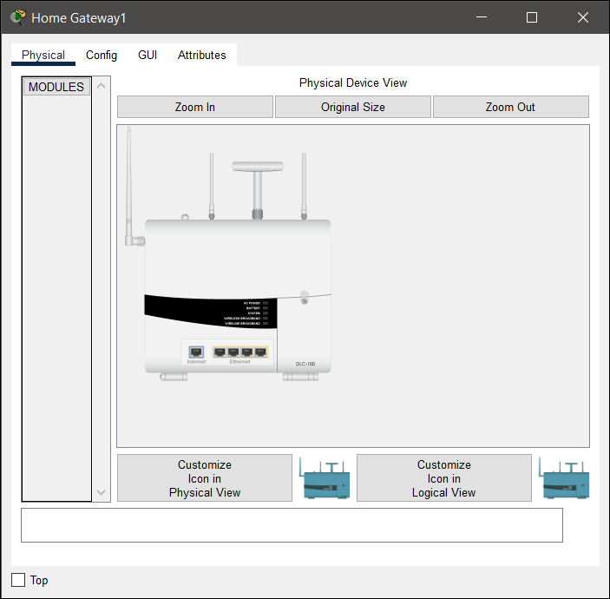

*Figure 2 Physical configuration of home gateway*

An IP address is an extraordinary number that can be utilized to recognize each host (PCs, switches, switches, etc) on an organization.[17] Whenever a host sends information to the IP address of a second getting host, it incorporates the originator's IP address, the objective's IP address, and extra information. While investigating network challenges, realizing the IP address of fundamental organization parts like switches, firewalls, and servers can be useful. Ping or Trace Route are two devices that can assist with detaching issue spots. In Figure 3 we can see the LAN IP configuration.

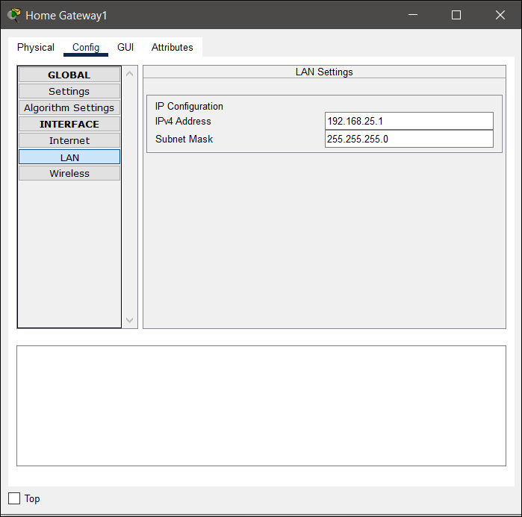

*Figure 3 Home Gateway IP Address*

[18] The association between the home gateway and the devices is displayed in Figure 4. The means underneath ought to be followed to arrange and enlist savvy IoT devices with a home door. Select the devices, then pick remote connector from the organization connector choice rundown in the I/O config. Select config to affirm that the devices is associated with the right SSID through wifi. From that point forward, go to Config/Settings and pick the home passage as the IoT server enrollment devices.

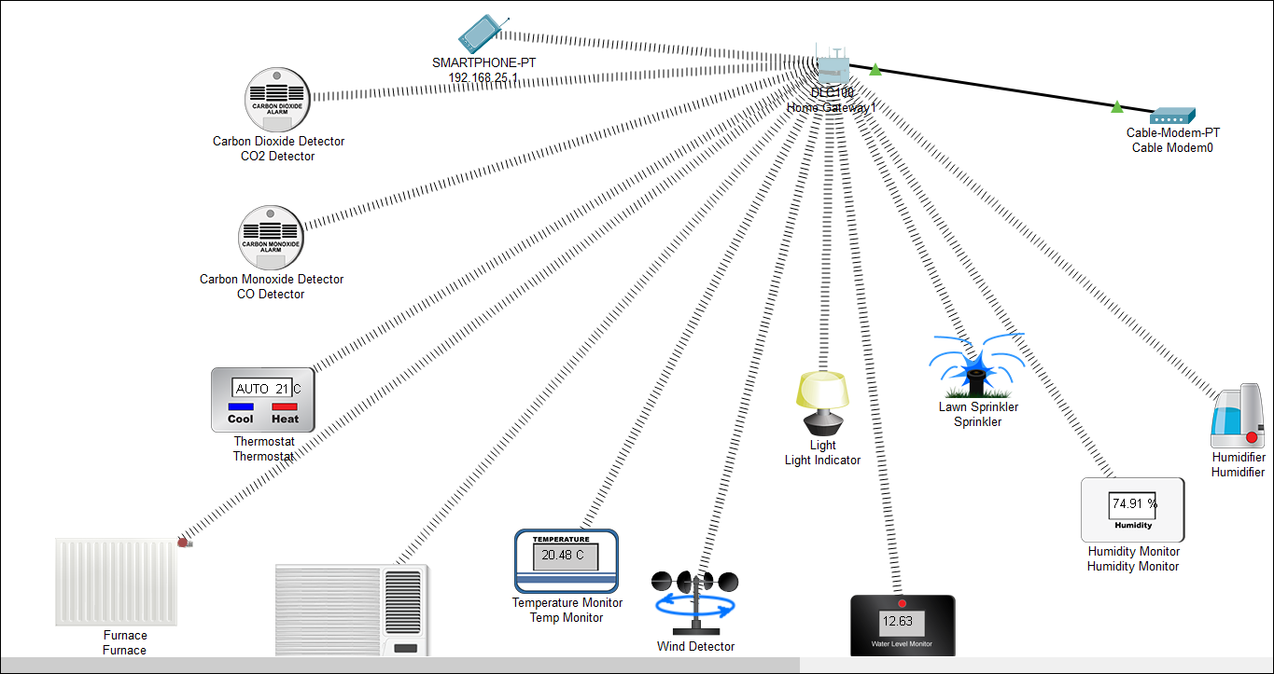

*Figure 4 Device connection with home gateway*

***B. Automatic Sprinkler System***

[19] A lawn sprinkler, water level screen, wind detector, and light marker make up the programmed sprinkler framework. The water level screen is utilized to recognize the presence of water. The water level screen's boundaries can be tweaked to address the client's issues. At the point when the water level arrives at the base required level, the yard sprinkler is switched off and the water channel is turned on naturally. Additionally, on the off chance that the water level is underneath the expected level, it actuates the sprinkler. [20] Whenever the water system framework is turned on, a light will enlighten to caution the clients. This component of a programmed yard sprinkler framework dodges the downsides of manual water system framework observing. Lawn sprinkler and other devices can also be controlled manually.

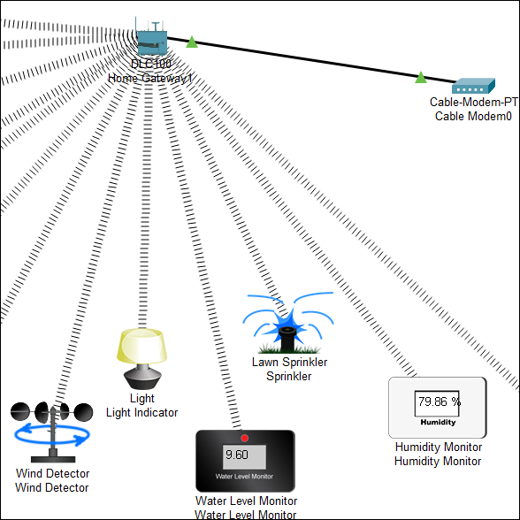

*Figure 5 Lawn Sprinkler System*

***C. Humidity Monitor System***

[21] The significance of humidity monitoring checking in water system couldn't possibly be more significant. Savvy dampness observing can work on the chances of good yield and productive water system. Figure 6 portrays the Humidity Monitoring System, one of the highlights of a brilliant water system framework. A dampness sensor is utilized in this framework. Stickiness sensors recognize how much dampness in the air. [22] The home passage has this sensor enrolled. The upsides of the mugginess sensor can be gotten to on the Tablet after the organization arrangements have been finished. A humidifier is likewise used to make it more advantageous.

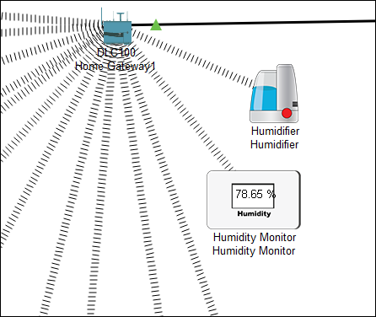

*Figure 6 Humidity Monitor System*

[23] A humidifier is a devices that builds how much dampness in the air. Clients can change the values by just simple logging into tablet and going for command. Figure 7 is showing the illustration of the commands for each device.

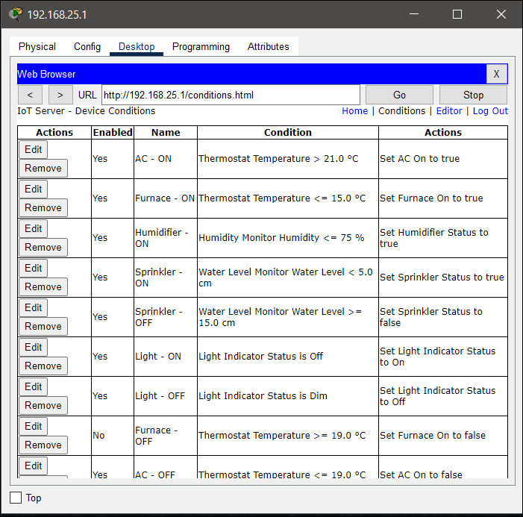

*Figure 7 IoT Device Condition and their actions.*

***D. Other IoT Server Devices***

Because of regular varieties in air force, the germination season of seeds and plants might be abbreviated.[24] This framework incorporates an Atmospheric Pressure Level Indicator for precise checking of climatic tension levels and the execution of proper advances that might support plant development and make more gigantic and fast root development.[25] One more element is the humiture meter, which helps with temperature and dampness observing. Temperature levels in the environment are estimated by the temperature screen. The Wind Detector recognizes the presence of wind in the encompassing region. Carbon monoxide and carbon dioxide finders, separately, identify carbon monoxide and carbon dioxide levels.

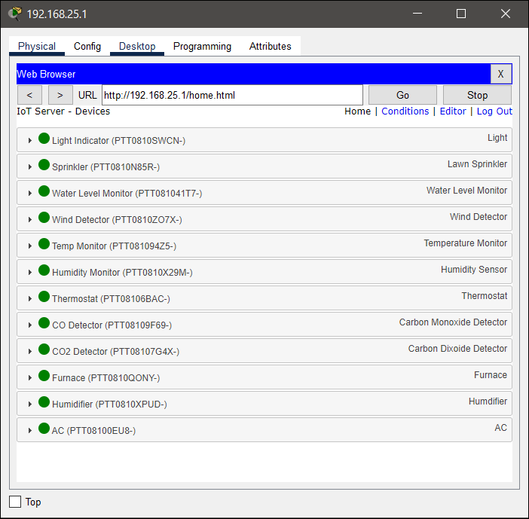*Figure 8 Display of IoT Devices on Smart Phone*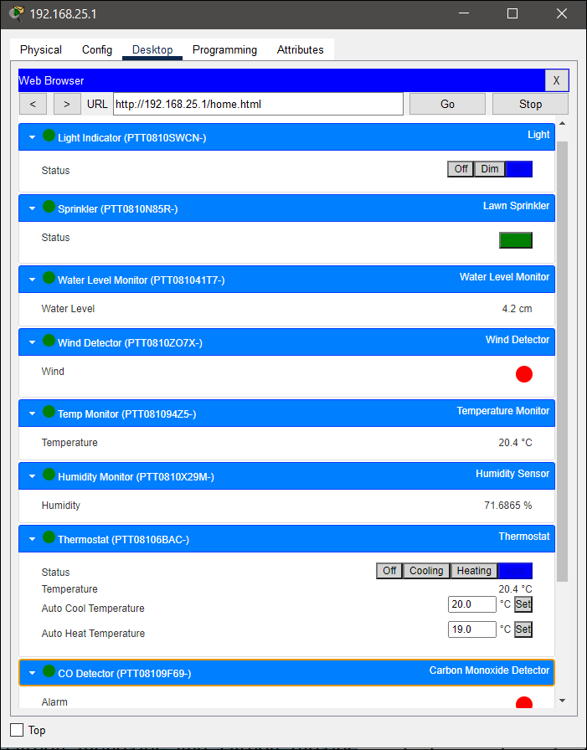

*Figure 9 Display of numerical values of sensors*

# **RESULTS AND DISCUSSION**

In the wake of enlisting the devices with the home gateway, you can utilize a smartphone to remotely control the IoT devices. Any smart device could be used for the monitoring and controlling all the IoT devices as well as viewing all the devices on the IoT monitor which can be controlled remotely. On the smartphone, you can see all of the enrolled IoT device. Devices might be controlled physically, and the qualities can be inspected and observed continuously. The values of the sensors that will be shown on the smartphone are displayed in the figure above. It shows the situation with the IoT device that has been connected with the home gateway. These devices can be controlled and monitored remotely from the smartphone as well as manually if needed.

# **CONCLUSION AND FUTURE SCOPE**

The Cisco packet tracer is utilized to build an Irrigation water system framework. A home gateway that permits you to enlist your contraptions and control them from your tablet. The client can screen all of the IoT devices connected to the home gateway both physically and from a distance. The discoveries demonstrate the way that this model can be utilized in certifiable circumstances. Water utilization can be diminished by executing a programmed water system framework. It is feasible to physically screen the framework, which can further develop energy productivity and set aside cash. It likewise simplifies it for the client to get the entirety of the data.

# **REFERENCES**

[1] K. Shafique, B. A. Khawaja, F. Sabir, S. Qazi, and M. Mustaqim, “Internet of things (IoT) for next-generation smart systems: A review of current challenges, future trends and prospects for emerging 5G-IoT Scenarios,” *IEEE Access*, vol. 8, pp. 23022–23040, 2020, doi: 10.1109/ACCESS.2020.2970118.

[2] S. B. Saraf and D. H. Gawali, “IoT based smart irrigation monitoring and controlling system,” *RTEICT 2017 - 2nd IEEE Int. Conf. Recent Trends Electron. Inf. Commun. Technol. Proc.*, vol. 2018-Janua, pp. 815–819, 2017, doi: 10.1109/RTEICT.2017.8256711.

[3] P. Kumari and S. K. Singh, “Smart irrigation system using IoT,” *Smart Comput.*, pp. 137–141, 2021, doi: 10.1201/9781003167488-18.

[4] M. Nagarajapandian, R. Savitha, and D. Shanthi, “An Advanced Irrigation System for Smart Agriculture Using the Internet of Things,” *Lect. Notes Electr. Eng.*, vol. 851, pp. 619–629, 2022, doi: 10.1007/978-981-16-9154-6_57.

[5] S. Vaishali, S. Suraj, G. Vignesh, S. Dhivya, and S. Udhayakumar, “Mobile integrated smart irrigation management and monitoring system using IOT,” *Proc. 2017 IEEE Int. Conf. Commun. Signal Process. ICCSP 2017*, vol. 2018-Janua, pp. 2164–2167, 2018, doi: 10.1109/ICCSP.2017.8286792.

[6] B. Alomar and A. Alazzam, “A Smart Irrigation System Using IoT and Fuzzy Logic Controller,” *ITT 2018 - Inf. Technol. Trends Emerg. Technol. Artif. Intell.*, no. 1, pp. 175–179, 2019, doi: 10.1109/CTIT.2018.8649531.

[7] D. Masseroni *et al.*, “Evaluating performances of the first automatic system for paddy irrigation in Europe,” *Agric. Water Manag.*, vol. 201, pp. 58–69, 2018, doi: 10.1016/j.agwat.2017.12.019.

[8] F. Adenugba, S. Misra, R. Maskeliūnas, R. Damaševičius, and E. Kazanavičius, “Smart irrigation system for environmental sustainability in Africa: An Internet of Everything (IoE)

approach,” *Math. Biosci. Eng.*, vol. 16, no. 5, pp. 5490–5503, 2019, doi: 10.3934/mbe.2019273.

[9] O. Sihombing *et al.*, “Smart home design for electronic devices monitoring based wireless gateway network using cisco packet tracer,” *J. Phys. Conf. Ser.*, vol. 1007, no. 1, 2018, doi: 10.1088/1742-6596/1007/1/012021.

[10] M. A. Harris, S. Furnell, and K. Patten, “Comparing the Mobile Device Security Behavior of College Students and Information Technology Professionals,” *J. Inf. Priv. Secur.*, vol. 10, no. 4, pp. 186–202, 2014, doi: 10.1080/15536548.2014.974429.

[11] J. Pacheco, D. Ibarra, A. Vijay, and S. Hariri, “IoT security framework for smart water system,” *Proc. IEEE/ACS Int. Conf. Comput. Syst. Appl. AICCSA*, vol. 2017-Octob, pp. 1285–1292, 2018, doi: 10.1109/AICCSA.2017.85.

[12] N. Vijayakumar and R. Ramya, “The real time monitoring of water quality in IoT environment,” *IEEE Int. Conf. Circuit, Power Comput. Technol. ICCPCT 2015*, 2015, doi: 10.1109/ICCPCT.2015.7159459.

[13] F. A. Almalki, “Implementation of 5G IoT based smart buildings using VLAN configuration via cisco packet tracer. International Journal of Electronics Communication and Computer Engineering,” vol. 11, no. 4, pp. 56–67, 2020.

[14] I. Shemsi, “Boosting Campus Network Design Using Cisco Packet Tracer,” *Int. J. Innov. Sci. Res. Technol.*, vol. 2, no. 11, 2017, [Online]. Available: www.ijisrt.com

[15] N. S. Tarkaa, P. I. Iannah, and I. T. Iber, “Design and Simulation of Local Area Network Using Cisco Packet Tracer,” *Int. J. Eng. Sci.*, pp. 2319–1813, 2017, doi: 10.9790/1813-0610026377.

[16] R. R. Chaudhari, K. K. Joshi, N. Joshi, and M. Kumar, “Smart and secure home using IOT Simulations with Cisco Packet Tracer,” *Int. J. Sci. Res. Comput. Sci. Eng. Inf. Technol.*, pp. 88–93, 2020, doi: 10.32628/cseit206311.

[17] T. P. Deepa, “Simulating Internet of Surveillance Using Packet Tracer,” *Int. J. Sci. Res. Comput. Sci. Eng. Inf. Technol. © 2018 IJSRCSEIT*, vol. 3, no. 10, pp. 1288–1295, 2018, [Online]. Available: http://index.html.

[18] P. Wang, “Teaching Internet of Things (Iot) Through Software Simulations With Packet Tracer,” *Issues Inf. Syst.*, vol. 21, no. 2, pp. 123–134, 2020, doi: 10.48009/2_iis_2020_123-134.

[19] K. Frank, N. Gravestock, M. Spearpoint, and C. Fleischmann, “A review of sprinkler system effectiveness studies,” *Fire Sci. Rev.*, vol. 2, no. 1, p. 6, 2013, doi: 10.1186/2193-0414-2-6.

[20] Anon, “Sprinkler Systems.,” *Natl Saf News*, vol. 117, no. 6, pp. 49–56, 1978.

[21] Y. Zhou, Q. Zhou, Q. Kong, and W. Cai, “Wireless temperature & humidity monitor and control system,” *2012 2nd Int. Conf. Consum. Electron. Commun. Networks, CECNet 2012 - Proc.*, pp. 2246–2250, 2012, doi: 10.1109/CECNet.2012.6201725.

[22] J. Islam *et al.*, “Design and Development of Microcontroller Based Wireless Humidity Monitor,” *IOSR J. Electr. Electron. Eng.*, vol. 13, no. 2, pp. 41–46, 2018, doi: 10.9790/1676-1302034146.

[23] J. G. Ramani, A. Lakshmipriya, S. Madhusudan, P. J. R. Kishore, M. Madhisha, and U. Preethi, “Solar Powered Automatic Irrigation Monitoring System,” *2020 6th Int. Conf. Adv. Comput. Commun. Syst. ICACCS 2020*, pp. 293–297, 2020, doi: 10.1109/ICACCS48705.2020.9074220.

[24] T. Shah and S. Venkatesan, “Authentication of IoT Device and IoT Server Using Secure Vaults,” *Proc. - 17th IEEE Int. Conf. Trust. Secur. Priv. Comput. Commun. 12th IEEE Int. Conf. Big Data Sci. Eng. Trust. 2018*, pp. 819–824, 2018, doi: 10.1109/TrustCom/BigDataSE.2018.00117.

[25] Win Sandar Aung | Saw Aung Nyein Oo, “Monitoring and Controlling Device for Smart Greenhouse by using Thinger.io IoT Server,” *Int. J. Trend Sci. Res. Dev.*, vol. 3, no. 4, pp. 1651–1656, 2019, doi: https://doi.org/10.31142/ijtsrd25212.

